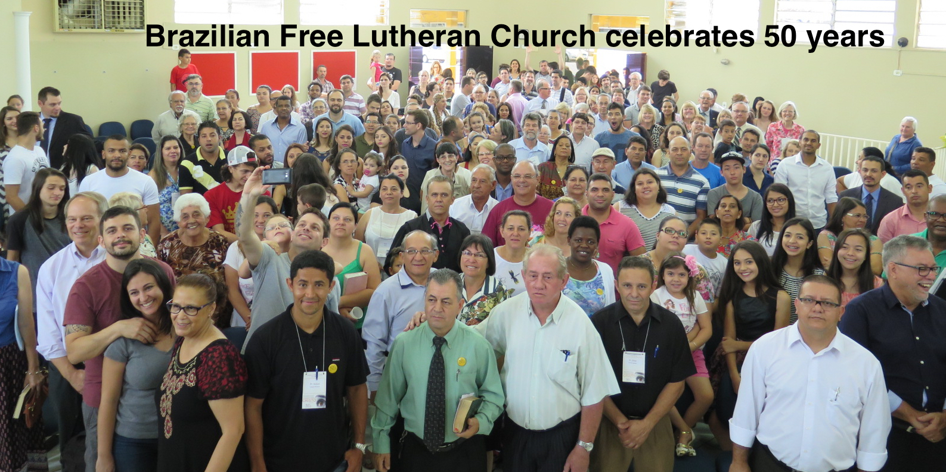
March 2017 Update from Paul and Becky

Run with Perseverance...Looking to Jesus!

Heb. 12:1-2

Yes, we are still in the race! The mission of running well and persevering as we look to Jesus has taken so much of our time and energy that we have not taken time to write and let you know the details about our marathon. We are reminded constantly that our supporters keep us energized through prayer and financial provision. For YOU we are extremely grateful. May the Lord renew your commitment to invest in His work through us even though at times you probably feel quite disconnected from your missionaries "far away in Brazil." We hope this update will draw you a bit closer to us. It was fun for us to receive many Christmas letters updating us on our friends and family back in the U.S. I decided to use a similar format in mentioning highlights from the last months with photos and short comments. Some news is better than no news, so here we go....

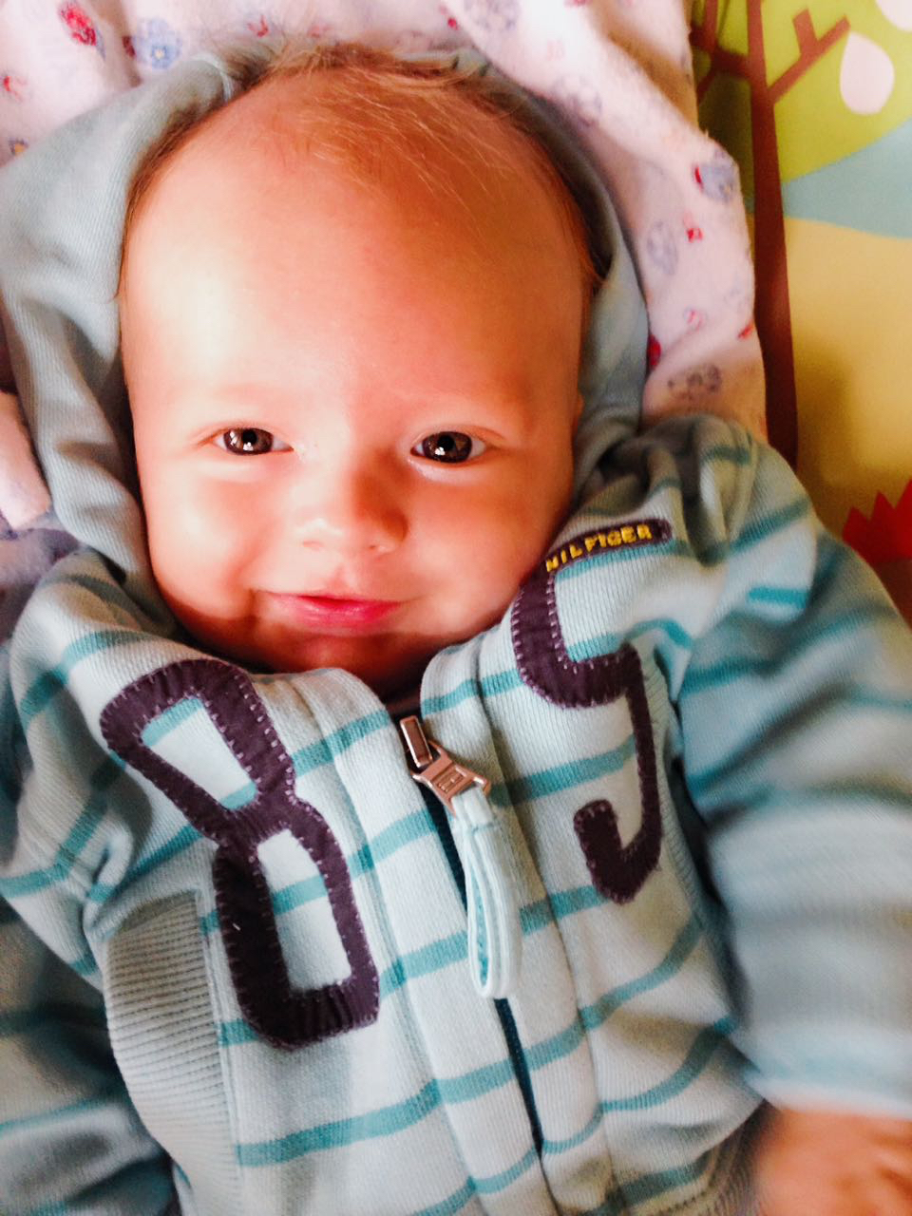
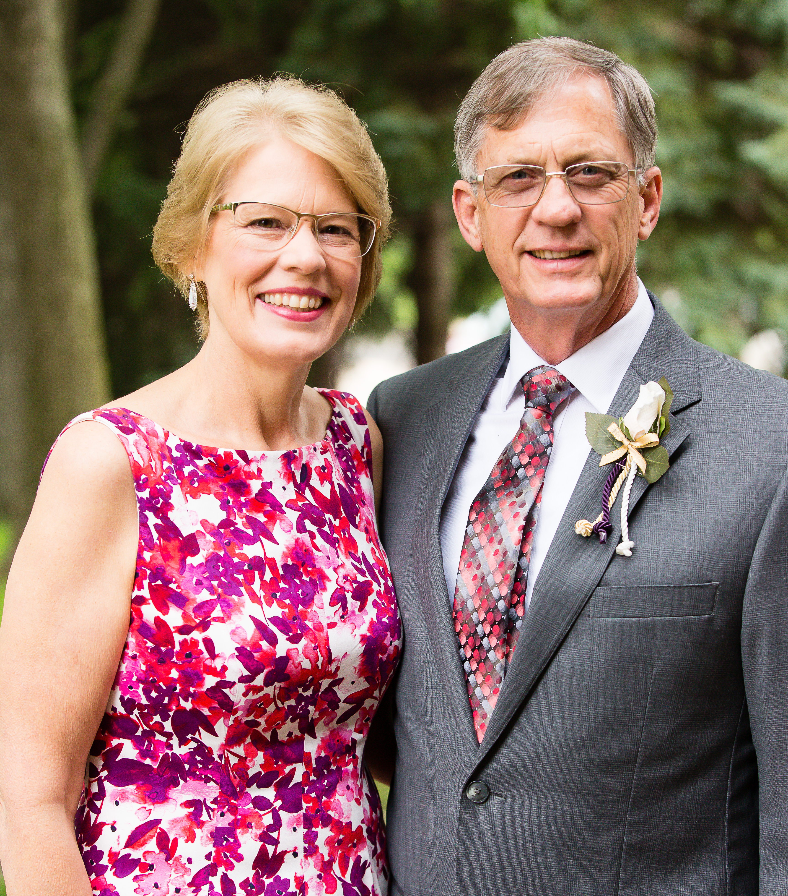
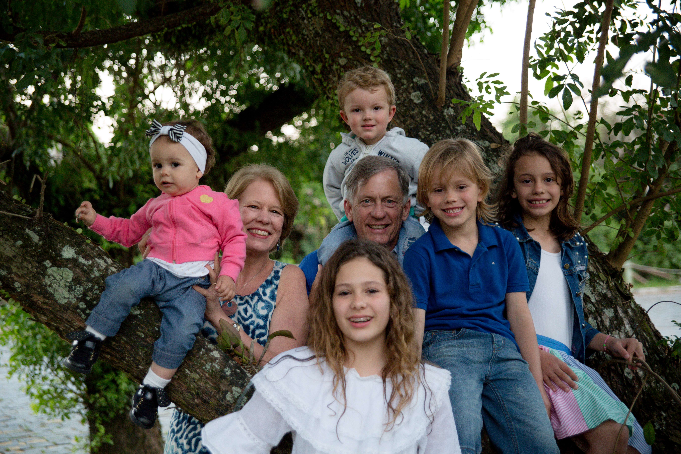
FAMILY
In August we had the opportunity to take a quick trip to the U.S. for a wedding and time to visit our relatives. We squeezed in many visits in a short time. My mother was having some serious health problems, so it was a blessing to be there for them. In September and October we have lots of birthdays, but the big one in 2016 was 60 years for me. Our children planned an unforgettable 3-day get away with the whole family. In November Christina gave birth to her second son, Nicholas, on her birthday, Nov. 18.
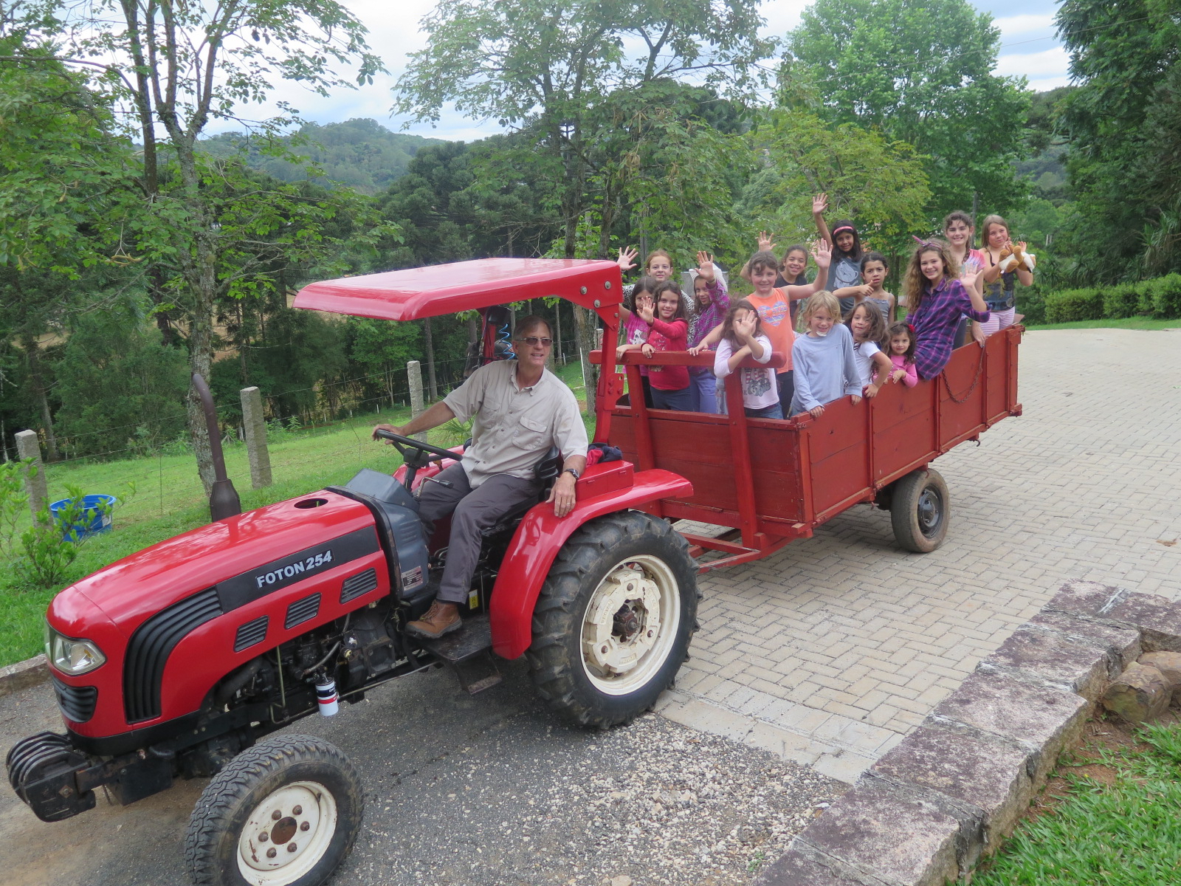
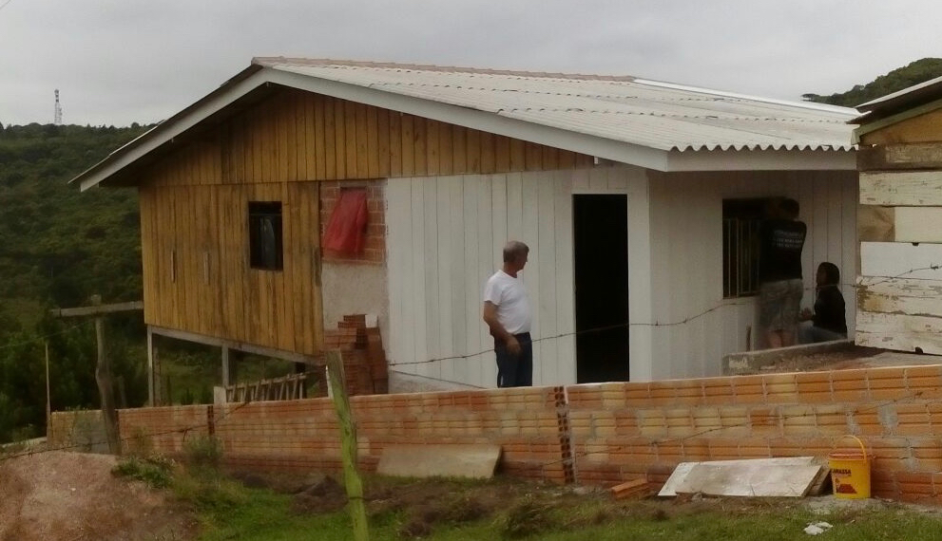
People and Outreach

The children love to have adventure with Paul around the ARCA. We were able to purchase a tractor that's been a big blessing. Paul is always working on projects to help people. He helped build a house for a needy family in 2016 and is already busy on another project for 2017. Pray for Brazil as they face so much corruption and economic instability. We have noticed a big increase in people needing help with basic living needs.
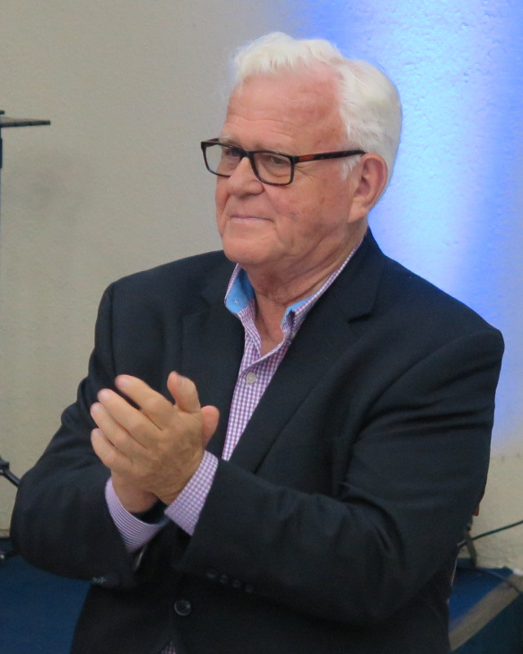
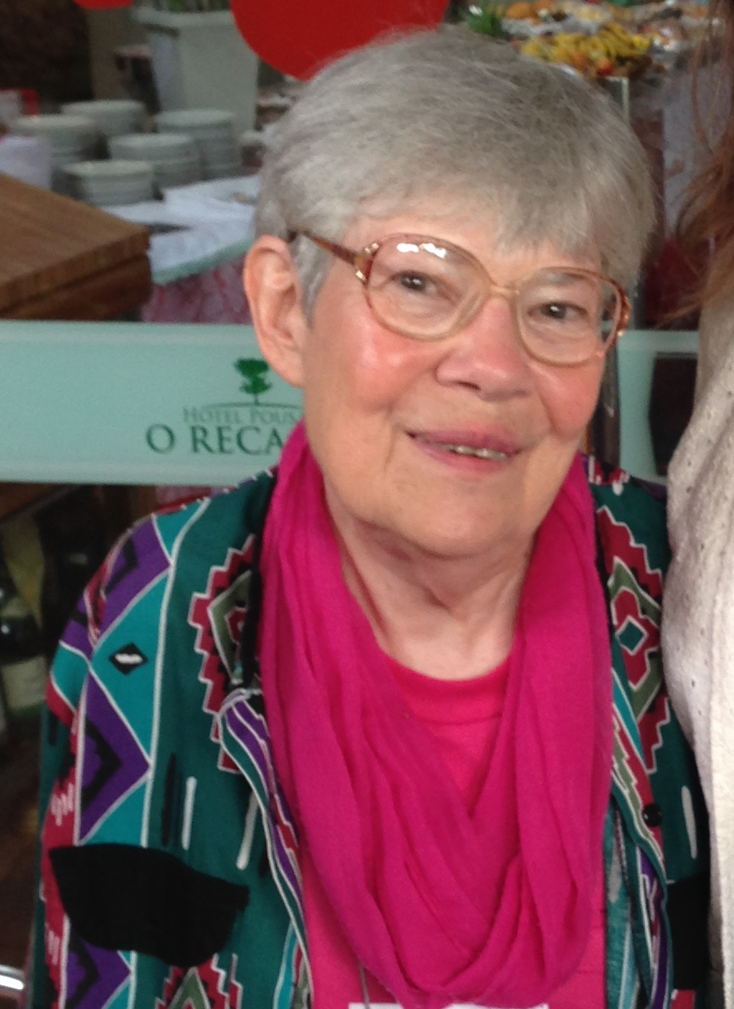
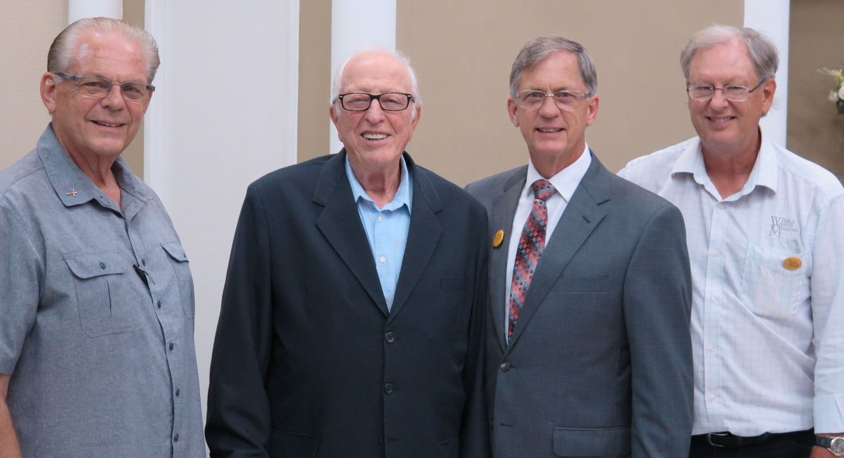
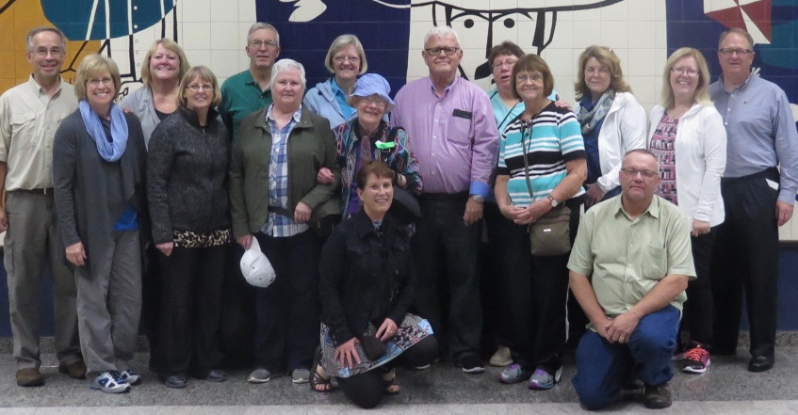
Priscilla Connely
Journey Missions group Wold Dyrud David, John, Paul, Jonathan Abel

30 Americans share in the 50th Anniversary celebration

It was great to have a Journey Missions group here in November which included several representatives from the AFLC including Del and Karen Palmer, Lyndon and Linda Korhonen, Connely Dyrud, Priscilla Wold Dutcher, Wanda Jacobson (our faithful secretary) and several of our supporters. It was really special to have Paul's folks, the founders of the AFLC in Brazil, with us to celebrate. His brother David who was a missionary here for 18 years also came for the festivities along with several other friends from the U.S. bringing the number of Americans to 30! All the work in preparing for the Conference was rewarded by a great time of fellowship. Paul was elected president of the Brazilian Free Lutheran church for 2017-2018, and I will be by his side as secretary. We have met twice this year and have plans to visit all of our churches during this year.

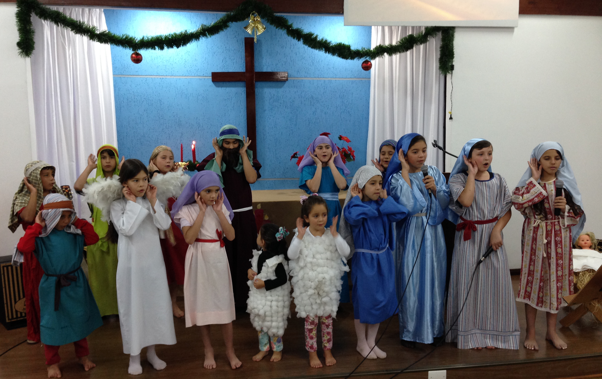
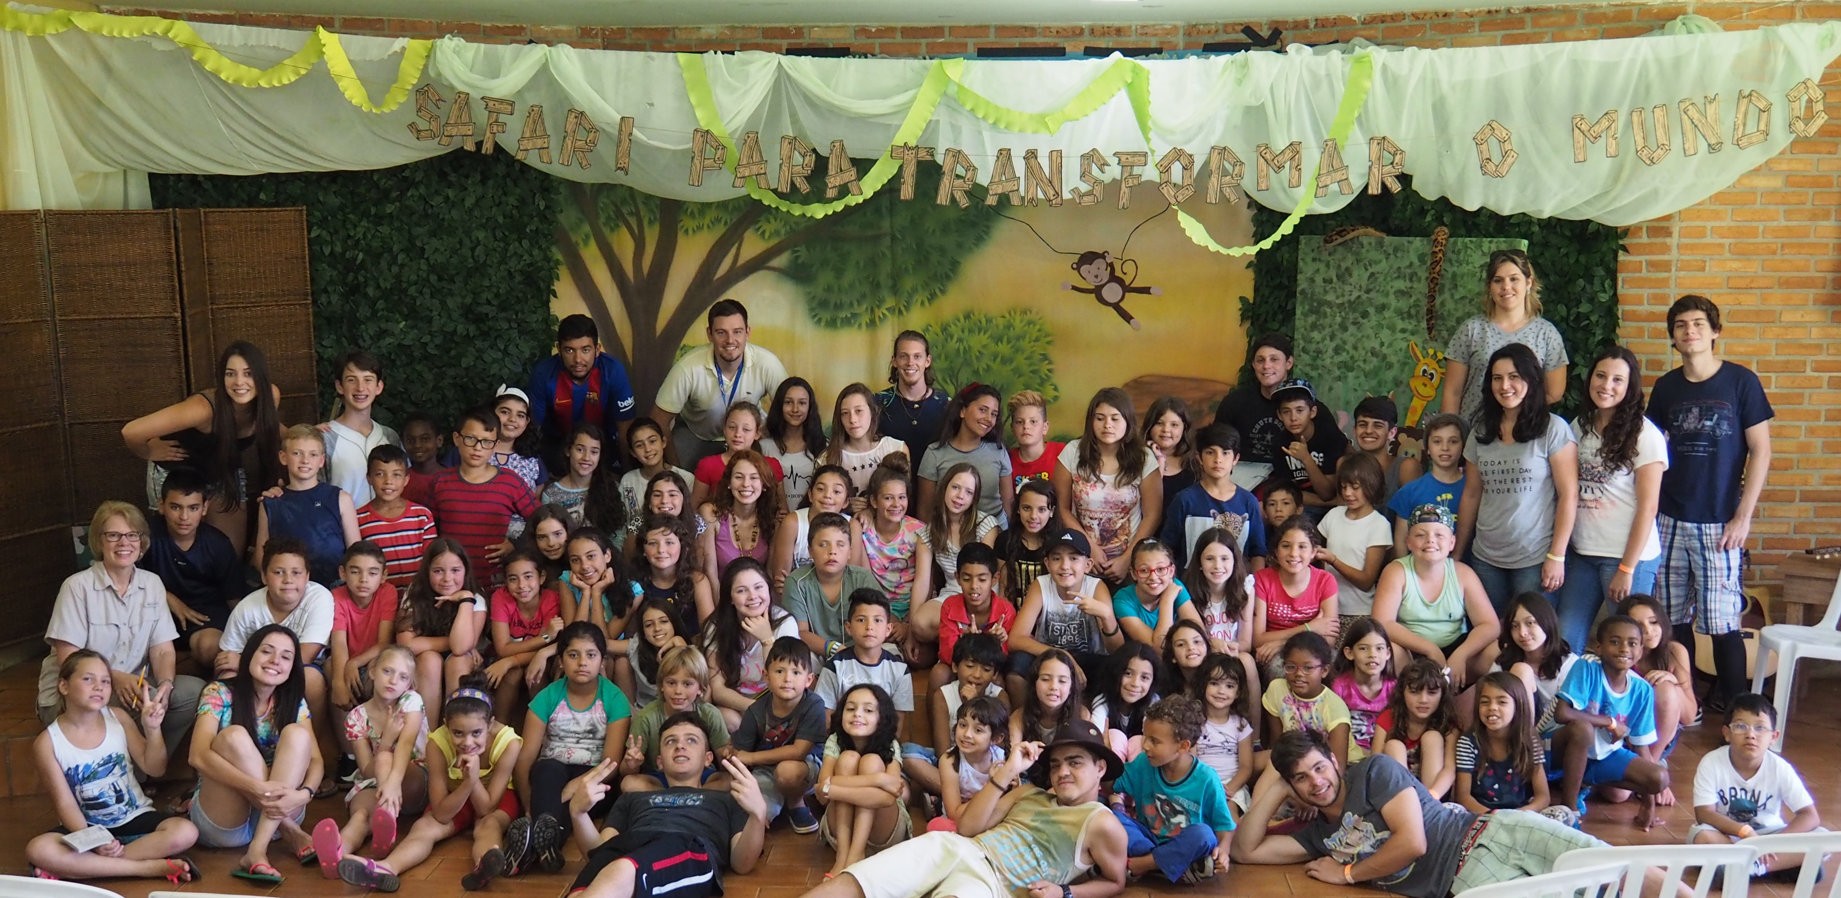
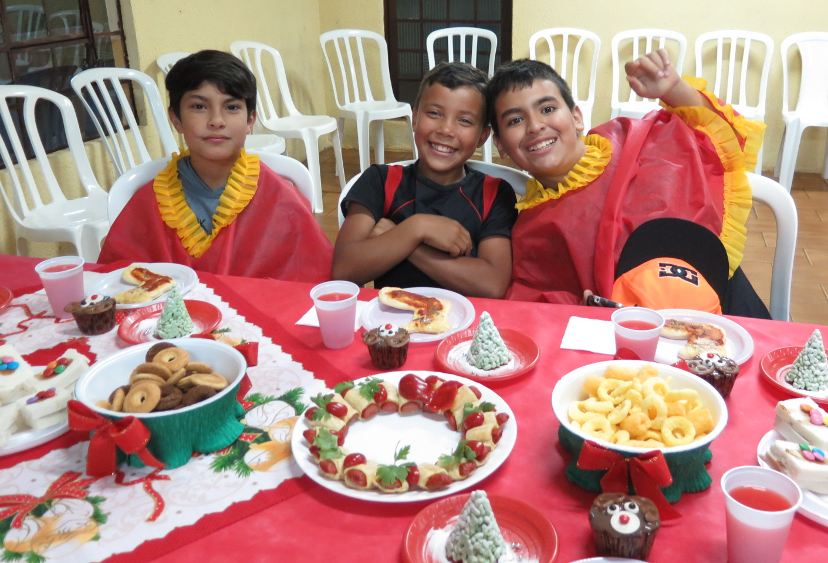
Events and Events
It seems like we are always planning a big event. In December we had a program with the English Club and programs at the churches. January is our month for Children's Camp. This year our theme was "Safari to Transform the World." We had a wonderful week with a missions emphasis! This week we just returned from our youth camp which was held in Campo Mourão this year. 70 people from the Curitiba area traveled there to be a part of the camp. And in just a few more days we will be hosting the Annual Women's Congress at the ARCA and are expecting a full house. In between events we seem to keep ridiculously busy with all the regular outreaches with which we are involved. I keep thinking we need to slow down, but we still haven't found the secret.
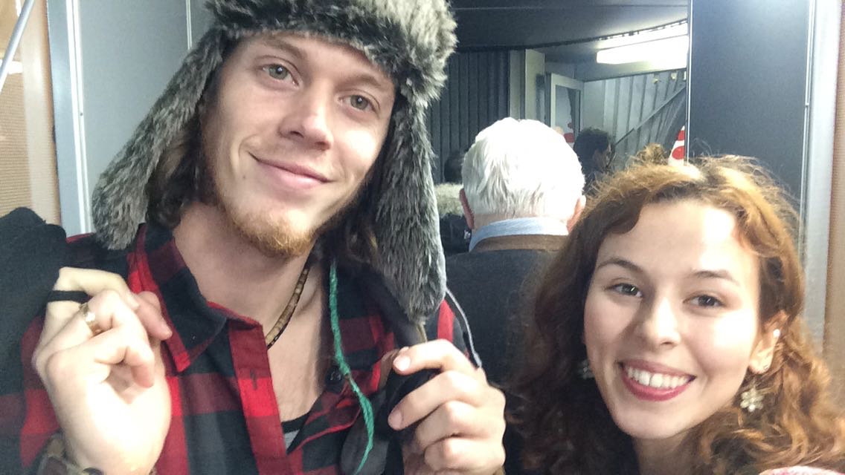
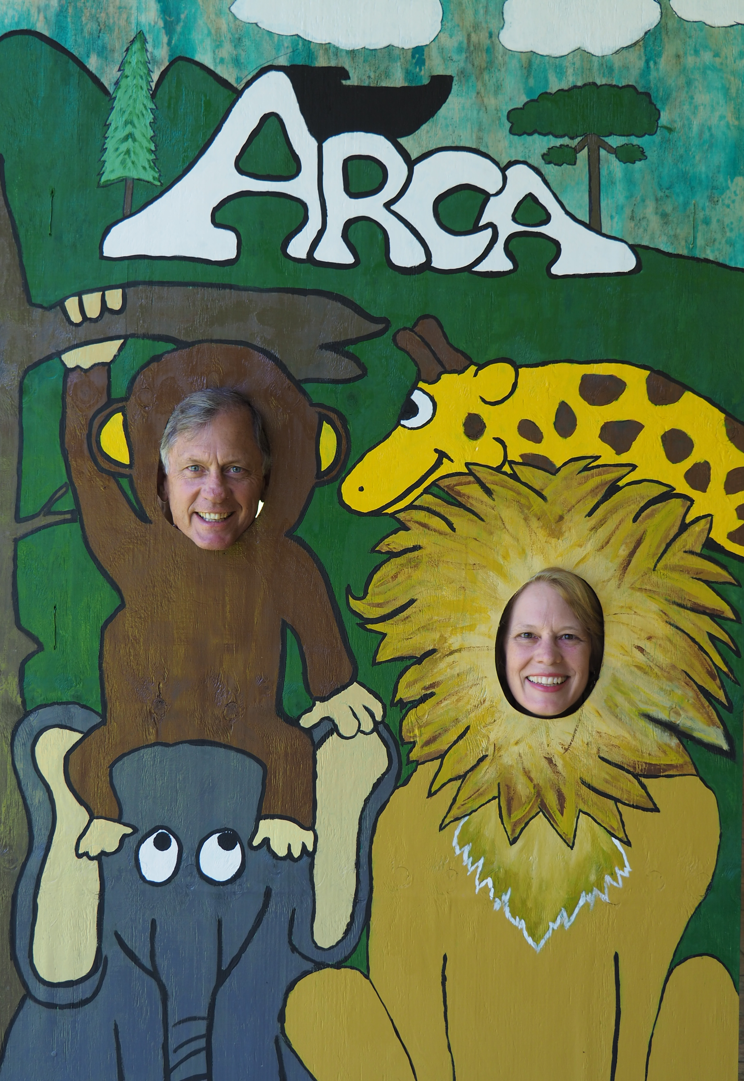
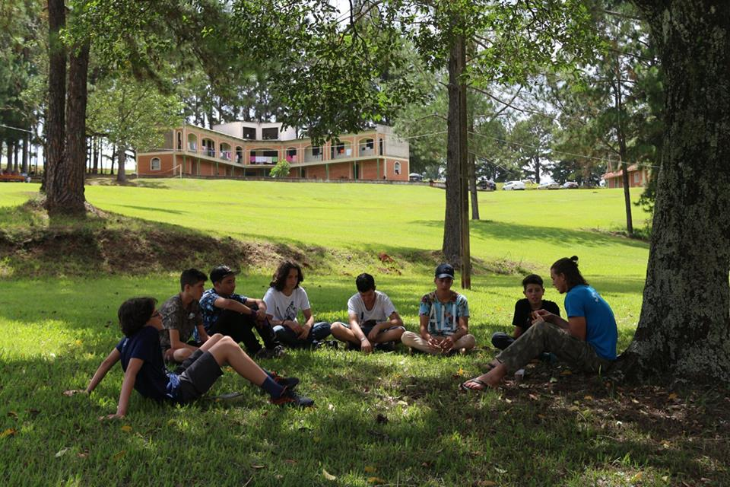

Matthew and Ednay spent three months helping our Brazilian pastor in Switzerland. They arrived back in Brazil in time for summer camps. This month we are working together to do a religious survey to canvas our neighborhood and invite people to our church. Soon we will be saying good-bye to them again as they are off to their next assignment in Maringá for three months.

1. Pray for us as we put together a program to share in the churches about what
it means to be Free Lutheran and as we travel to the churches and encourage pastors.
2. Pray for the people who came to Christ at camp.
3. Pray for the Women's Conference at the ARCA next weekend.
4. Pray for the visits in the neighborhood of our Bateias church.
Blessings to each of you as you pray for us and participate financially so that we can continue to make a difference in Brazil! Paul and Becky

(763) 390-6825 paulabelfamily@gmail.com www.paulabelfamily.org
AFLC World Missions 3110 E. Medicine Lake Blvd. Minneapolis, MN 55441

https://paulabelfamilydotorg.files.wordpress.com/2017/03/march-2017-update-from-paul-and-becky.pdf

